Kewalinvest 4th Round of testing--

- Contacts-

After Converting contact to customer ( test2), it should reflect in customer count as well as customer list ....once the contact converted to customer convert button should disappear for particular contact.
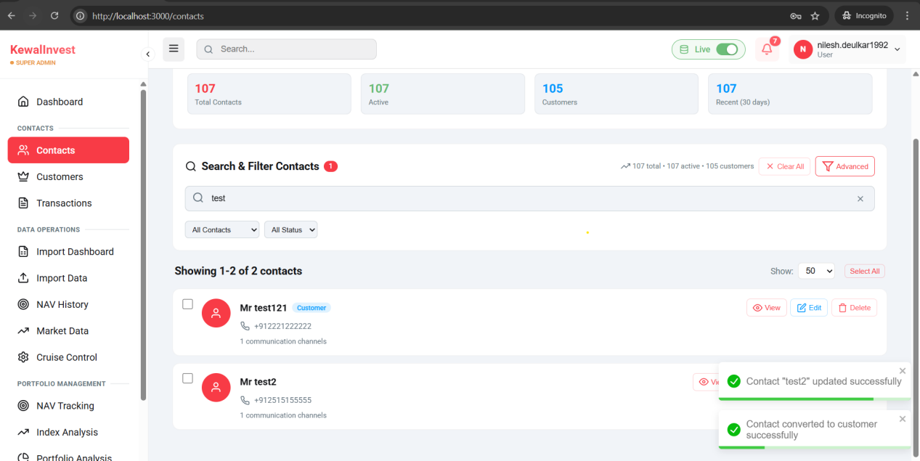
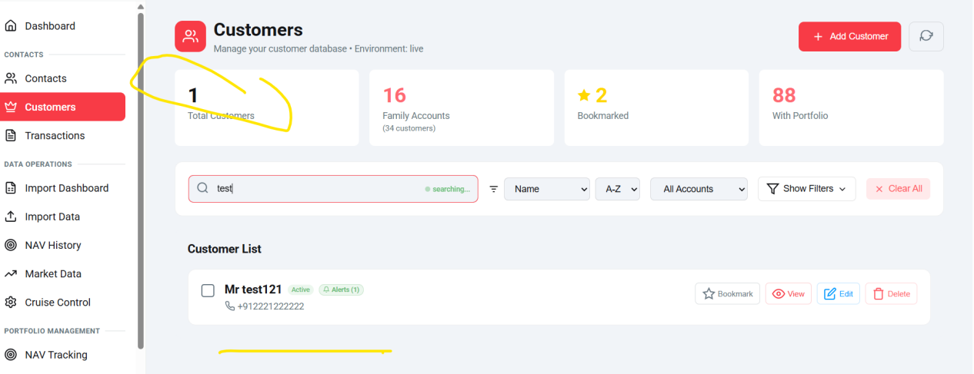

Same communication method should accept only one method as primary here its allowing to mark all as primary...
Communication channel un-tick is not working for Set as primary mobile channel..
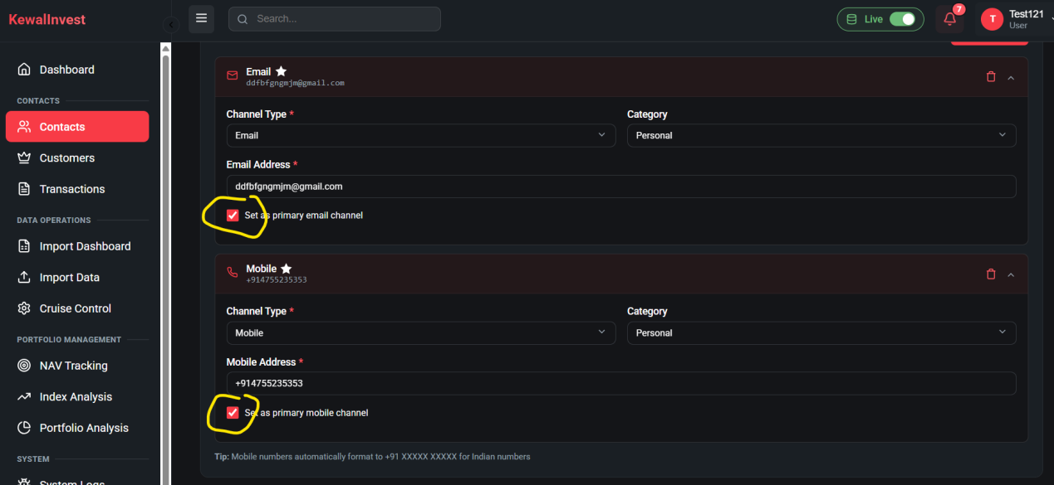

- Import Dashboard----Bookmark Data
There are difference in Count of Total records and successful , 7 records are missing..
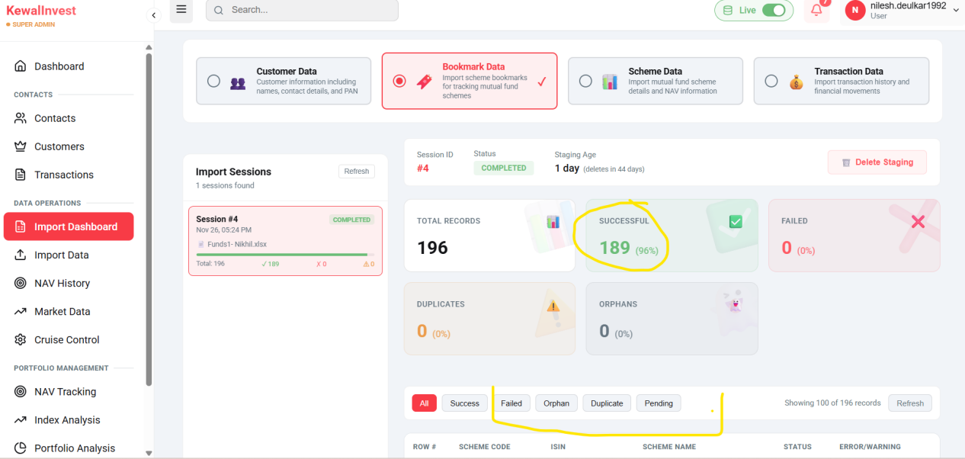

Import Dashboard
Under the Scheme bookmark list of data is showing only 100 records and next page is not showing further records..

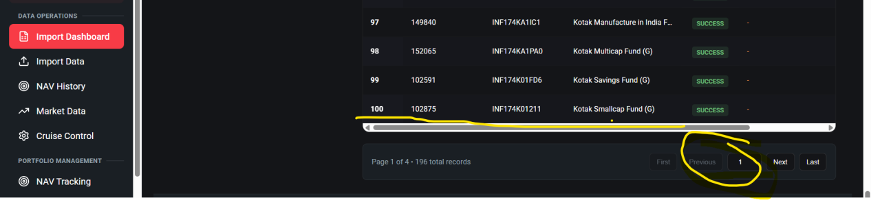
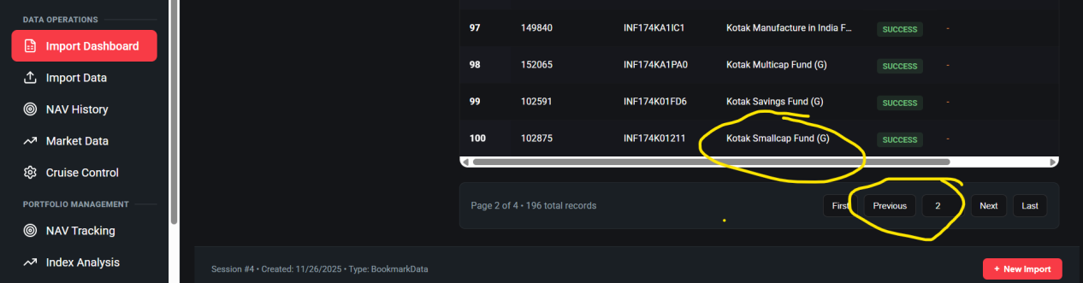

Orphans section is not showing orphan count but data is showing in list..
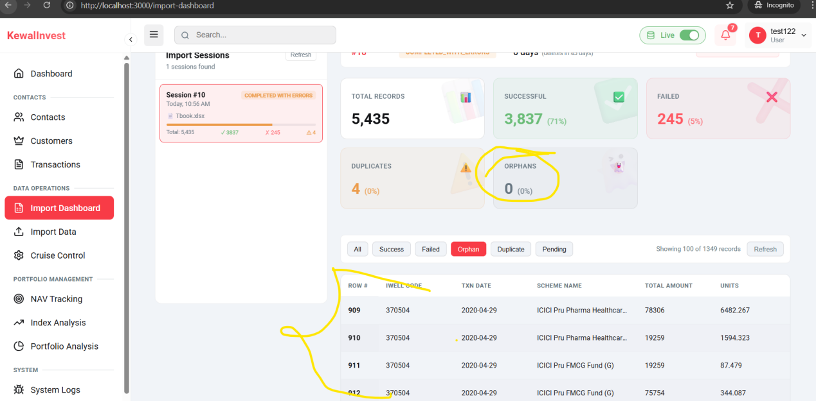

Networth projection calculated till 1 Year for 24M its showing same as 1Year--
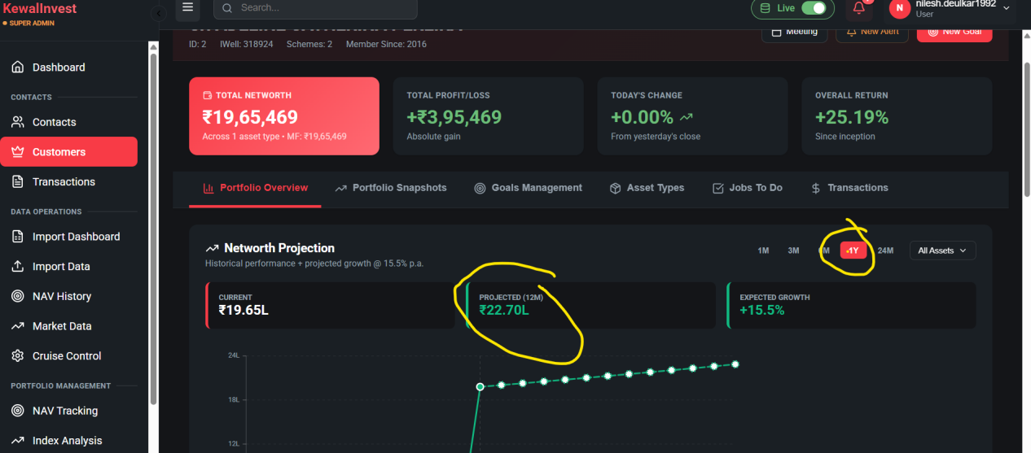

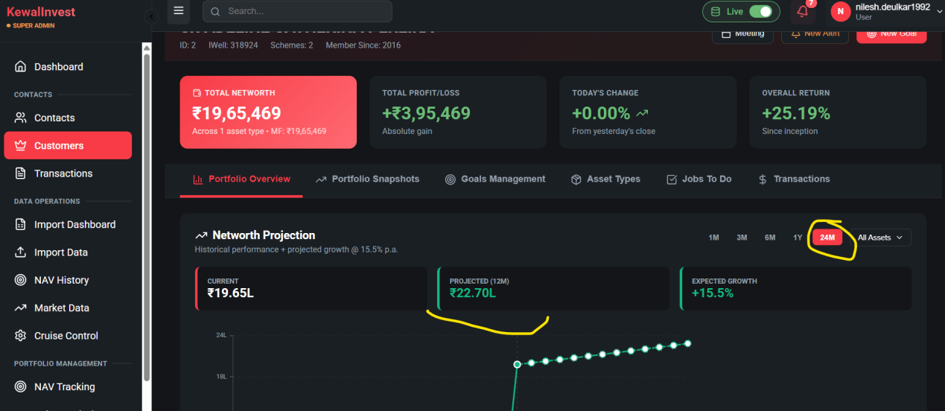

Customer -Edit is not updating new changes to customer details.
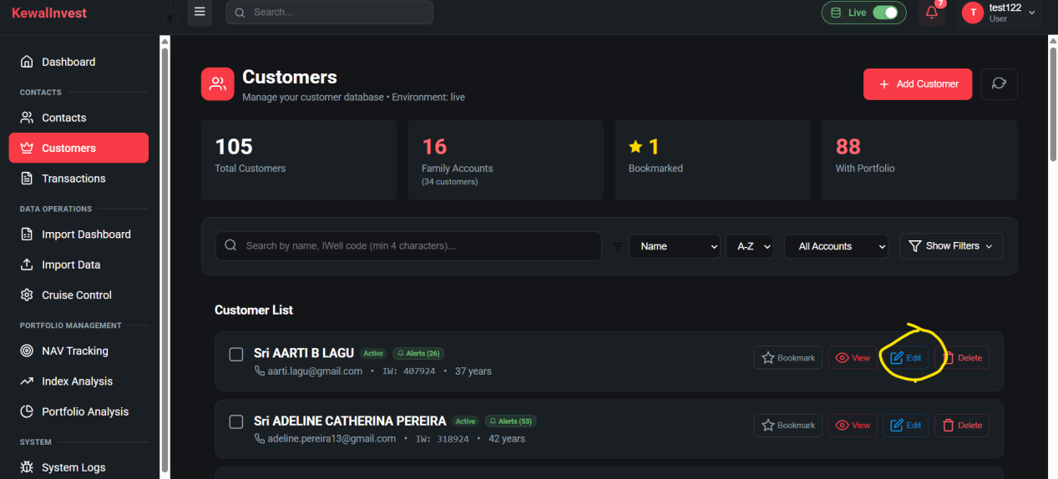

Customer-New Alert
Unable to create alert expecting table configuration in db-
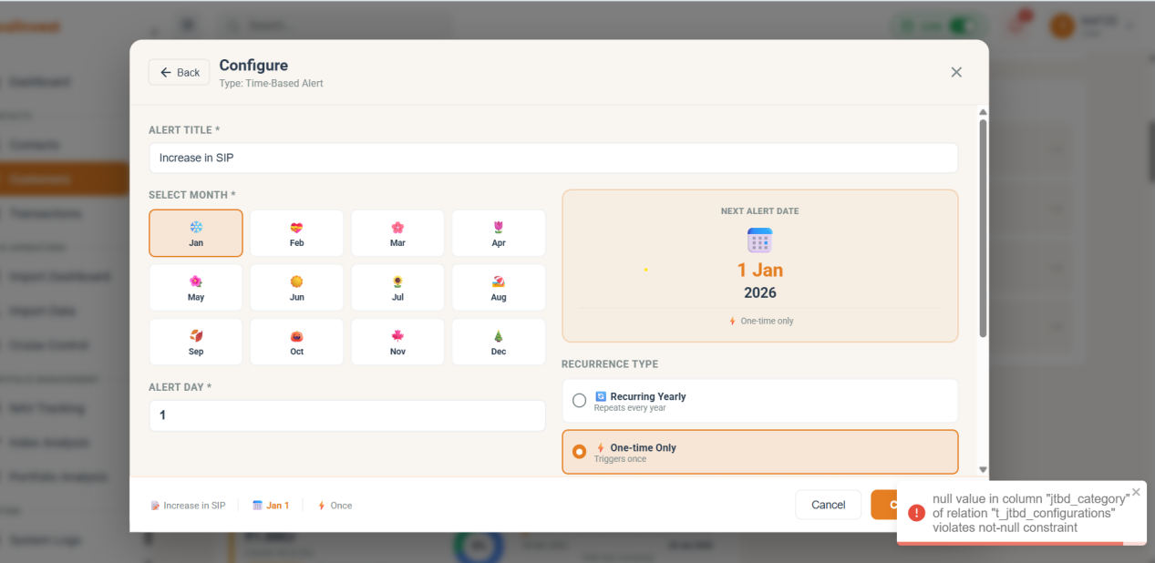

Transaction- Search by scheme name or code is not filtered the records..
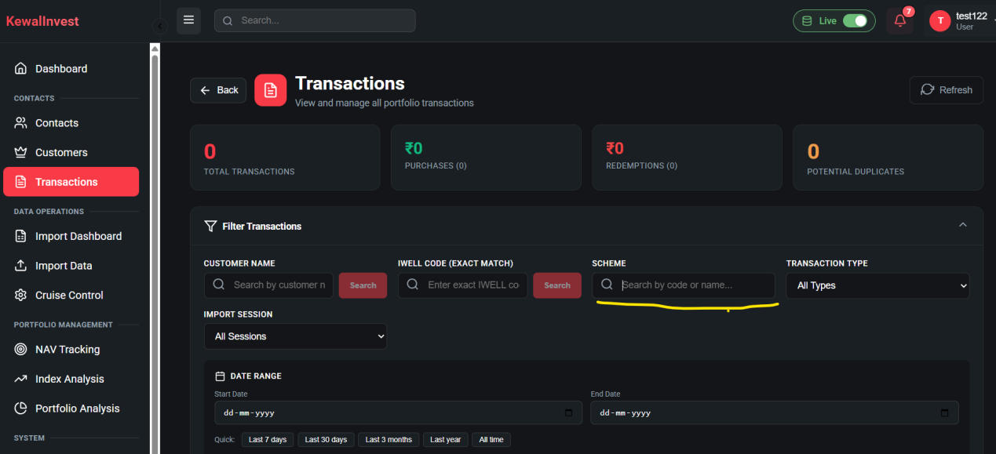

- Cruise Control
NAV downloads-- NAV Downloaded still its showing pending
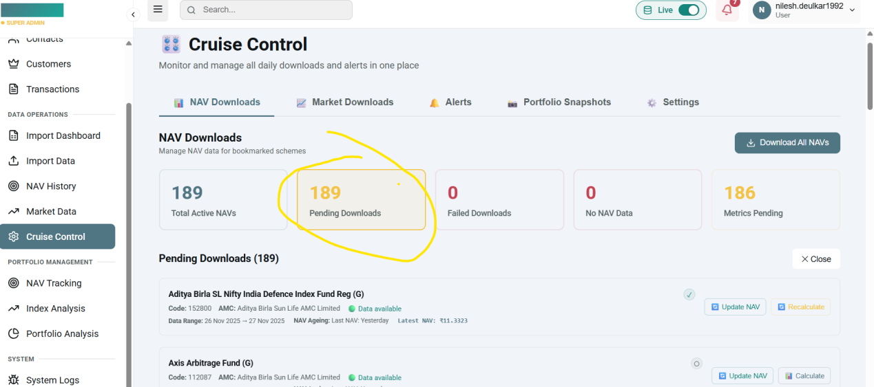

Cruise Control---NAV Downloads
Failed Downloads tab not showing failed count ..
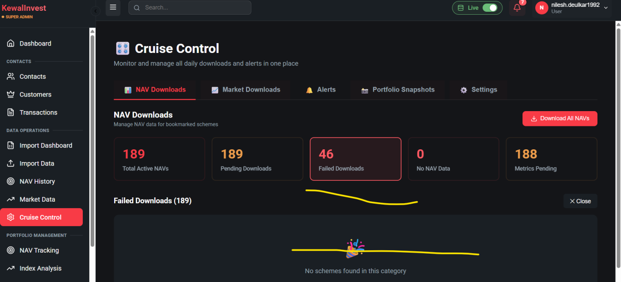

Customers-Transaction
In Customer Transaction history sort by filter is not showing the filtered records for all the scenarions newest, oldest, A-Z, Z-A
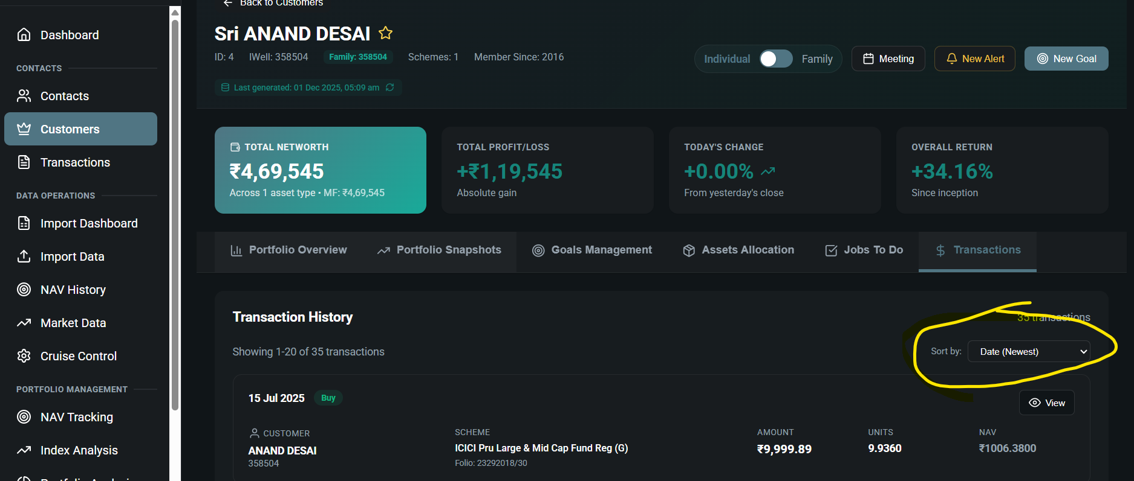

Customer--Porfolio Overview
After Clicking on Upcoming alerts it is redirecting to active goals-
